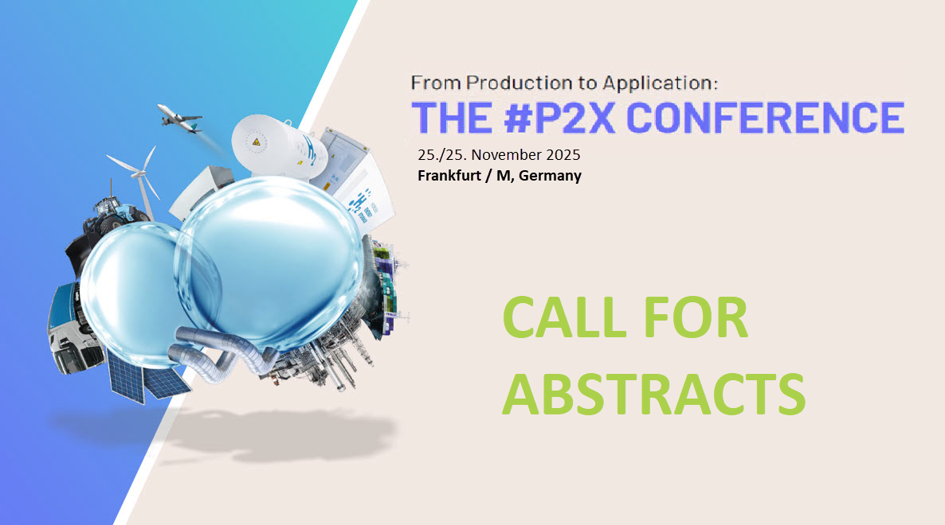

From Production to Application: THE #P2X CONFERENCE
25./26.11.2025, Frankfurt/M | expert presentations focused on
practical, technical challenges | specialists in dialogue | from industry professionals, for industry professionals | networking space |

From Production to Application: The #P2X Conference stands out by focusing on engineering practice. It delves into the technical challenges faced in specific projects and explores ways to overcome them. Attendees can learn valuable lessons from various projects, understand mistakes made, and discover how to avoid them. From Production to Application: The #P2X Conference is the ideal platform to engage with international P2X experts.

CALL FOR ABSTRACTS 2025
The conference takes place for the fourth time already. Like in the years before, it concentrates on technical challenges and covers a wide range of topics. These include
- electrolysis and other production pathways for hydrogen,
- syntheses for eFuels and other hydrogen derivates incl. ammonia and methanol,
- CCU for eFuels,
- challenges in construction and operation of plants producing or working with hydrogen or derivates,
- transport, storage and logistics P2X products,
- safety related issues,
- direct use of P2X products in process industries, chemistry, steelmaking, heating solutions, on- and off-road drives, ship propulsion, …
- technical-economic assessment of supply chains & their business cases in a national and international context.
We focus on contributions from industry. Would you like to be present in Frankfurt with your own presentation? If so, send us your abstract. Please concentrate particularly on technical practice: What are the specific technical challenges in your project and how can they be overcome? What prejudices have you had to struggle with, what technical mistakes can be avoided and how? What knowledge gaps still exist? What lessons have been learnt? Please prepare your abstract using the template on the following pages.
Abstract template 2025
From Production to Application:
THE #P2X CONFERENCE

Title of presentation you want to give

Topic of presentation (tick one or more boxes)
☐ Electrolysis & other production pathways for hydrogen
☐ eFuels and other hydrogen derivates
☐ Practical applications
☐ Transport and logistics of hydrogen and derivates
☐ Operation of hydrogen plants
Author (Author’s full name, company, job title, email address, phone number

Short description of the presentation you want to give,100 to 300 words

Please send your abstract to
Thomas Michaelis
thomas.michaelis@vdma.org
+49 69 6603 1810
The deadline for submission is 30.4.2025
Find additional information on the conference here: https://www.p2xconference.com/

